DIFFICULT
----------------------------------------------------------------------------------------------------------------------------
1. What is the difference between the throw and throws keywords in Java?
Ans:
- The throw and throws keywords are both used in Java for exception handling, but we use them for different purposes.
- The throw keyword is used within a block of code or a method.
- The throws keyword is used to declare that a method might throw an exception. It is used in the method signature, after the method’s return type and before the method’s parameters.
----------------------------------------------------------------------------------------------------------------------------

2. What is the purpose of the finalize() method in Java?
Why is it considered a bad practice to use it?
Ans: “finalize” is a method in java that is called by the garbage collector before an object is garbage collected and can be overridden to perform any necessary cleanup before the object is destroyed.
Finalize Method in Java is not guaranteed to be called at any particular time or at all. So relying on it for critical cleanup operations can be risky.
It can introduce performance issues, as the JVM must perform additional work to manage finalization and resurrected objects.

----------------------------------------------------------------------------------------------------------------------------

3. What is the difference between an abstract class and an interface in Java? When would you use one over the other?

Ans:
1. Abstract class can have abstract and non-abstract methods. Interface can have only abstract methods.
2. Abstract class achieves partial abstraction (0 to 100%) where interface achieves fully abstraction (100%).
3.Abstract class contains abstract keyword to declaration. Interface use Interface keyword
Uses:
You should use an abstract classs when you want to provide a base class for concrete subclasses to inherit from. And you should use an interface when you want to define a set of methods that a class must implement.
----------------------------------------------------------------------------------------------------------------------------

4. What is a Lambda expression in Java? Provide an example to explain its use.
Ans: A lambda expression is a short block of code which takes in parameters and returns a value. Lambda expressions are similar to methods , but they do not need a name and they can be implemented right in the body of a method.

Example:
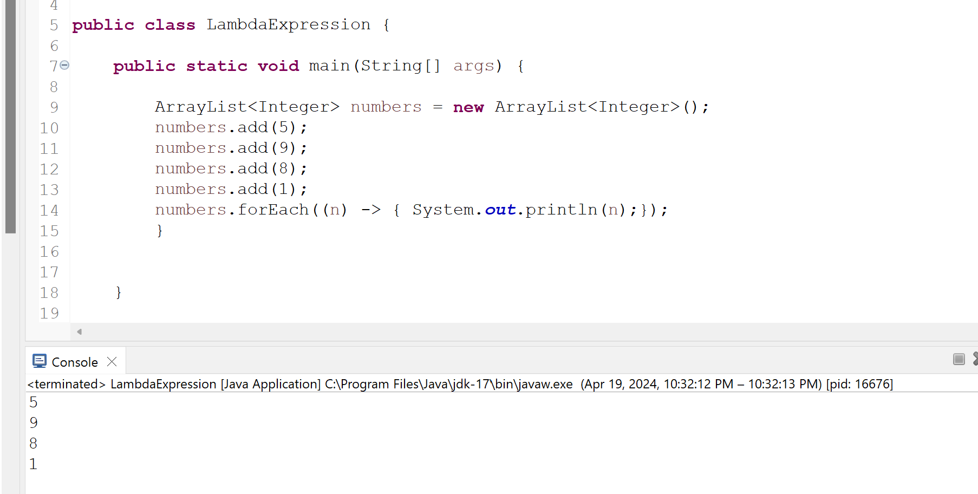
----------------------------------------------------------------------------------------------------------------------------
5. What is the difference between the continue and break statements in Java?
Ans:
The continue and break statements are both used to control the flow of a loop in Java. However, they work in different ways.The continue statement skips the rest of the current iteration of the loop and continues with the next iteration. The break statement terminates the loop entirely.
----------------------------------------------------------------------------------------------------------------------------
6. What is the purpose of the volatile keyword in Java? Provide an example to explain its use.
Ans:The volatile keyword in Java is used to indicate
that a variable value may be modified by multiple threads simultaneously. The volatile keyword is a powerful tool that can be used to ensure that shared data is always consistent in multithreaded applications. However, it is important to use the volatile keyword carefully, as it can also lead to performance problems if it is used incorrectly.

Public class VolatileExample{
private volatile int count = 0;
public void increment(){
count++;
}

public void getCount(){
return count;
}
}

----------------------------------------------------------------------------------------------------------------------------
7. What is the difference between ArrayList and LinkedList in Java? When would you use one over the other?
Ans: Both ArrayList and LinkedList are implementation
of List interface in Java. Both classes are non-synchronized. But there are certain differences as well
- ArrayList is slow as array manipulation is slower but LinkedList is faster being node based as not much bit shifting required.
- ArrayList Implements only List but LinkedList implements List as well as Queue.
- ArrayList is faster in storing and accessing data but LinkedList is faster in manipulation of data.

LinkedList should be used when frequent modification happens like addition/deletion operations. On the other hand, when the read scenarios is more than the addition or removal, then ArrayList takes precedence over LinkedList.

----------------------------------------------------------------------------------------------------------------------------
8. What is the difference between public, protected, and private access modifiers in Java?
Ans:
public : accessible from everywhere.
protected : accessible by the classes of the same package and the subclasses residing in any package.
private : accessible within the same class only.
----------------------------------------------------------------------------------------------------------------------------
9. What is an exception in Java? Provide an example to explain the concept.
Ans:
An exception in Java is an event that occurs during the execution of a program that disrupts the normal flow of the program's instructions. Exceptions can be caused by a variety of factors, such as:

User input errors:
For example, if a user enters an invalid value into a text field, the program may throw an exception.
System errors:
For example, if the program tries to access a file that does not exist, the program may throw an exception.
Programming errors:
For example, if a programmer makes a mistake in the code, the program may throw an exception.
----------------------------------------------------------------------------------------------------------------------------
10. What is the purpose of the static keyword in Java? Provide an example to explain its use.
Ans:
The static keyword in Java is used to share the same variable or method of a given class. The users can apply static keywords with variables, methods, blocks, and nested classes.
Example:

class Test
{
//static method
static void method1 (){
System.out.print(“Method 1”);
}
public static void main(String[] args){
//calling static method
method1();
}
}

----------------------------------------------------------------------------------------------------------------------------
11. What is a constructor in Java? Provide an example to explain its use.
Ans: The moment an Object is created, constructor is invoked. Constractor has same name as class name. Constructor has no return type. Constructor initialize the object and optimize the code.
Example:
public class Student{
String student_name;
int student_id;

public Student(String student_name, int student_id){
this.student_name = student_name;
this.student_id = student_id;
}
public static void main(String[] args){
Student stu1 = new Student(“John” , 101);
System.out.print(stu1.student_name + “---” + stu1.student_id);
}
}

----------------------------------------------------------------------------------------------------------------------------
12. What is the purpose of the interface keyword in Java? Provide an example to explain its use.
Ans: The interface keyword in java use to create interface class to achieve abstraction. Interfaces are also used to achieve polymorphism in Java.
Example:
Interface MiddleSchool
Interface MiddleSchool{
public void sixthGrade();
public void seventhGrade();
public void eightGrade();
}
Execution class
public class Execution implements MiddleSchool{
public static void main(String[] args){
MiddleSchool reference = new Execution();
}
@Override
public void sixthGrade(){
System.out.print(“sixth grade overriding”);
}

@Override
public void seventhGrade(){
System.out.print(“seventh grade overriding”);
}

@Override
public void eightGrade(){
System.out.print(“eight grade overriding”);
}

}

----------------------------------------------------------------------------------------------------------------------------
13. What is a thread in Java? Provide an example to explain the concept.
Ans: Thread is light process within a process. Java creates threads by using a Thread Class. Generally all the program have at least one thread, known as the main thread, that is provided by the JVM at the strating of the program’s execution. At this point, when the main thread is provided, the main() method is invoked by the main thread.

Thread can be created in two ways :
Extending Thread class and Implementing runnable interface.
Extending Thread class example:
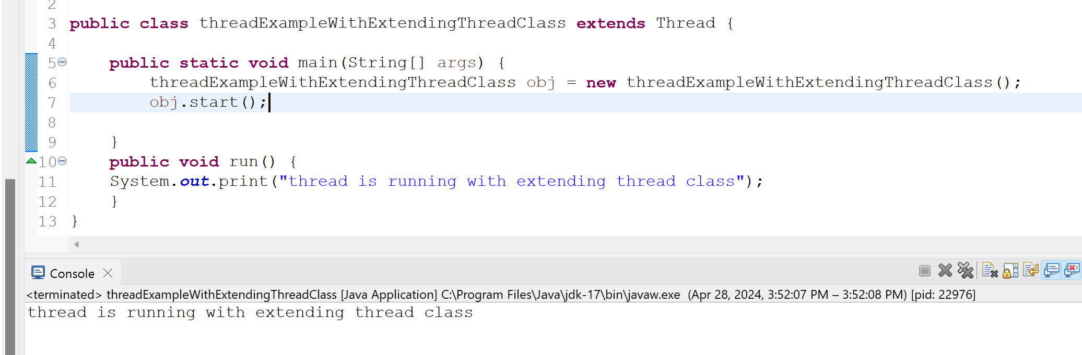

Implementing runnable interface example:
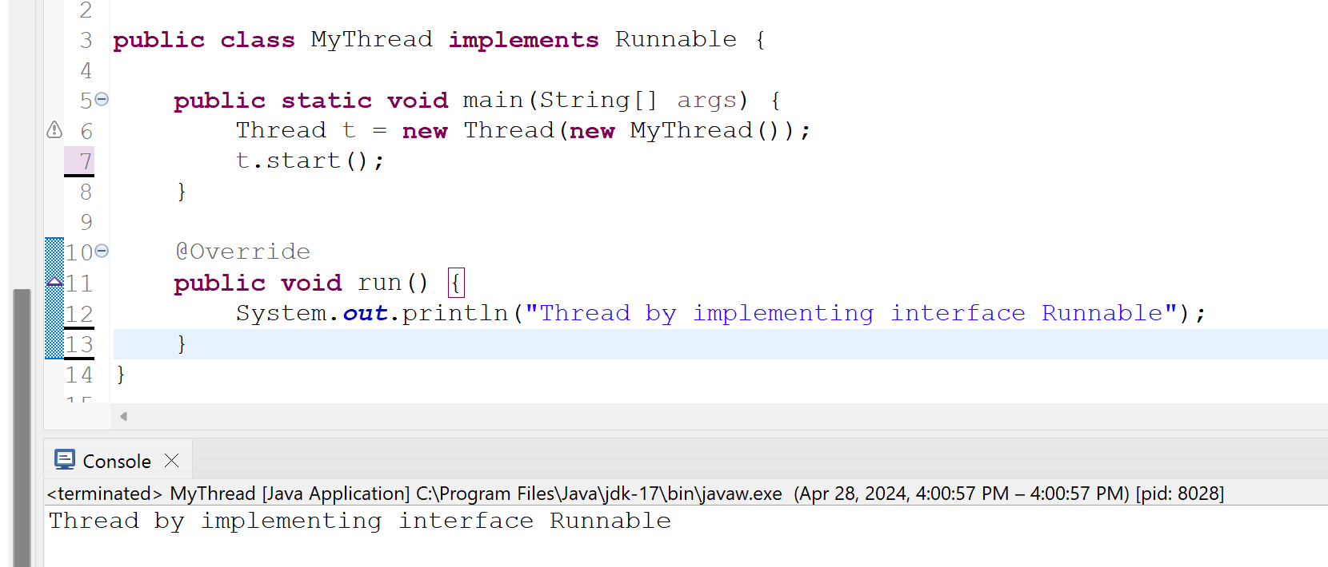
----------------------------------------------------------------------------------------------------------------------------
14. What is the purpose of the super keyword in Java? Provide an example to explain its use.
Ans:
The super keyword in Java is a reference variable which is used to refer immediate parent class object. Whenever you create the instance of subclass, an instance of parent class is created implicitly which is referred by super reference variable.
Usage of Java super Keyword
1. super can be used to refer immediate parent class instance variable.
2. super can be used to invoke immediate parent class method.
3. super() can be used to invoke immediate parent class constructor.
----------------------------------------------------------------------------------------------------------------------------
15. What is a package in Java? Provide an example to explain the concept.
Ans: Packages in Java to organize classes, packages, interfaces and also uses to prevent naming conflicts.

For Example: there can be two classes with name student in two packages, school.grade.seven.Student and school.grade.eight.Student

Making searching/locating and usage of classes, interfaces and annotations easier.

Providing controlled access : protected and default have package level access control. A protected member is accessible by classes in the same package and its subclasses. A default member is accessible by classes in the same package only.

----------------------------------------------------------------------------------------------------------------------------
16. What is a method in Java? Provide an example to explain the concept.
Ans: Methods are independent units of execution.
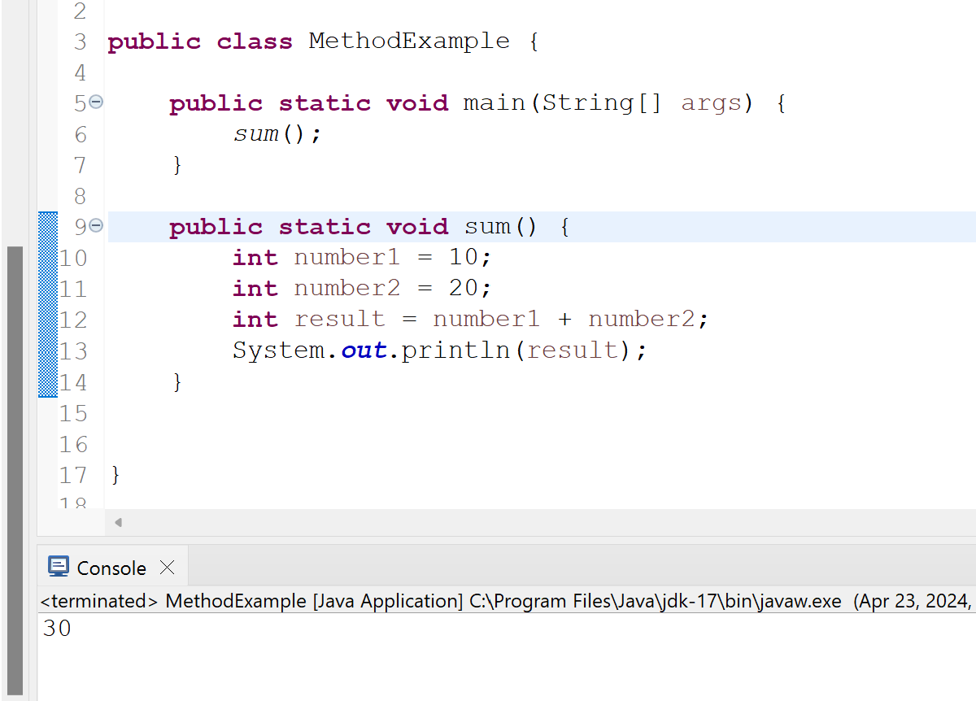
----------------------------------------------------------------------------------------------------------------------------
17. What is the difference between a HashMap and a TreeMap in Java? When would you use one over the other?
Ans:
HashMap:
- Java HashMap is a hashtable based implementation of Map Interface.
- HashMap allows a single num key and multiple null values.
- HashMap allows heterogeneous elements because it does not perform sorting on keys.
- HashMap is faster than TreeMap because it provides constant-time performance that is for the basic operations like get() and put().
- The HashMap class uses the hash table.

TreeMap:
- Java TreeMap is a Tree structure-based implementation of Map interface.
- TreeMap does not allow null keys but can have multiple null values.
- TreeMap allows homogeneous values as a key because of sorting.
- TreeMap is slow in comparison to HashMap because it provides the performance of O(Log(n)) for most operations like add(), remove(), and contains().
- TreeMap internally uses Red-Black tree, which is a self-balancing Binary Search Tree.

The HashMap should be used when we do not require key-value pair in sorted order.The TreeMap should be used when we require key-value pair in sorted order.
----------------------------------------------------------------------------------------------------------------------------
18. What is the purpose of the assert keyword in Java? Provide an example to explain its use.
Ans: It is mainly used for testing purposes during development. An assert statement is used with a Boolean expression and can be written two different ways.
For example:
first : assert expression;
second: assert expression1: expression2;
public static void main(String[] args){
int age=14;
assert age<18 : “cannot vote”;
System.out.print(“The voter age is ” + age);
}

----------------------------------------------------------------------------------------------------------------------------
19. What is the difference between final, finally, and finalize keywords in Java?
Ans:
final:
- final is a keyword and access modifier which is used to apply restrictions on a class, method or variable.
- Once declared , final variable becomes constant and cannot be modified.
- Final method cannot be overridden by subclass.
- Final class cannot be inherited.
Finally:
- finally is the block in Java Exception Handling to execute the important code whether the exception occurs or not
- finally block is always related to the try and catch block in exception handling
- finally block runs important code even if exception occurs or not.
- Finally block is executed as soon as the try-catch block is executed.

Finalize:
- finalize is the method in java which is used to perform clean up processing just before is garbage collected.
- Finalize() method is used with the objects.
- Finalize method is executed just before the object is destroyed.

----------------------------------------------------------------------------------------------------------------------------
20. What is polymorphism in Java? Explain with an example.
Ans: The word polymorphism means having many forms. In simple words. Polymorphism allows us to perform a single action in different ways.
For Example: The print() method is also an example of polymorphism. It is used to print values of different types like char, int, string etc.
----------------------------------------------------------------------------------------------------------------------------
21. Write a program to implement a binary search tree in Java.
----------------------------------------------------------------------------------------------------------------------------
22. Write a program to implement a doubly-linked list in Java.
----------------------------------------------------------------------------------------------------------------------------
23. Write a program to sort an array of objects in Java using the quicksort algorithm.
----------------------------------------------------------------------------------------------------------------------------
24. Write a program to implement a stack using a linked list in Java.
----------------------------------------------------------------------------------------------------------------------------
25. Write a program to implement a queue using two stacks in Java.
----------------------------------------------------------------------------------------------------------------------------
26. Write a program to find the longest common subsequence of two strings in Java.
----------------------------------------------------------------------------------------------------------------------------
27. Write a program to find the maximum subarray sum in an array of integers in Java.
Ans:
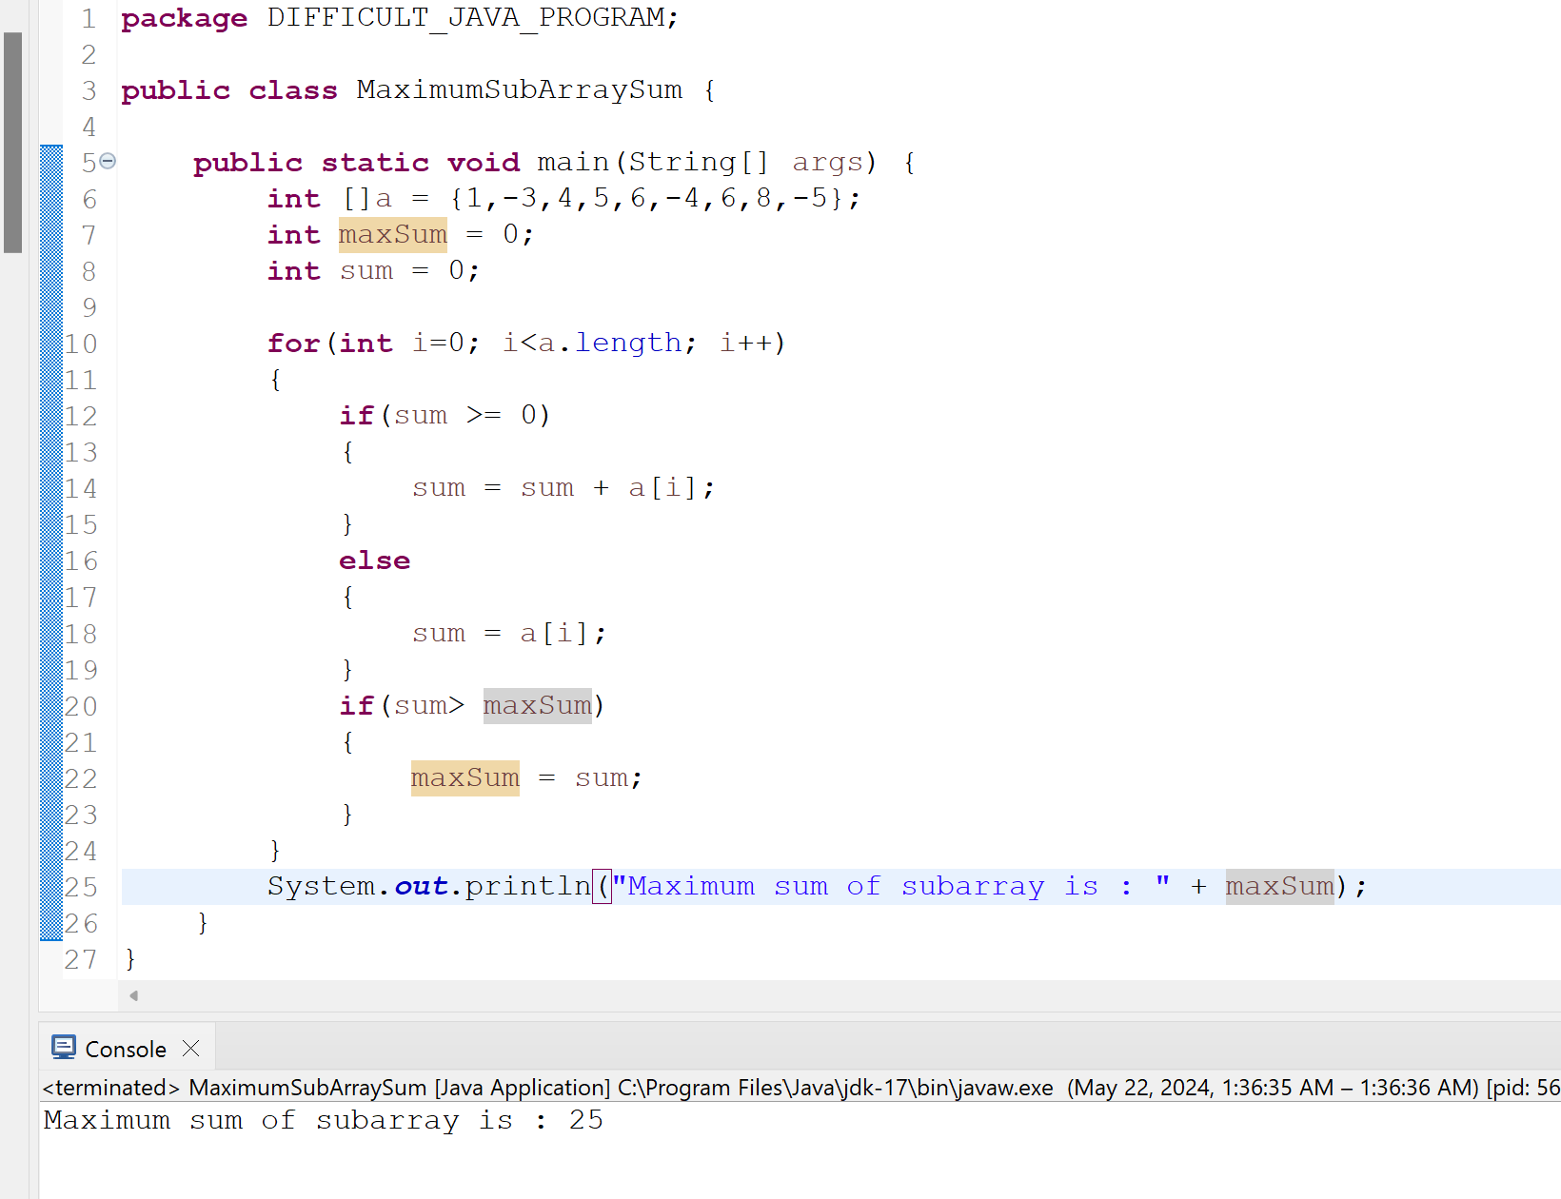

----------------------------------------------------------------------------------------------------------------------------
28. Write a program to implement a merge sort algorithm in Java.?
----------------------------------------------------------------------------------------------------------------------------
29. Write a program to implement a binary search algorithm for a rotated sorted array in Java.
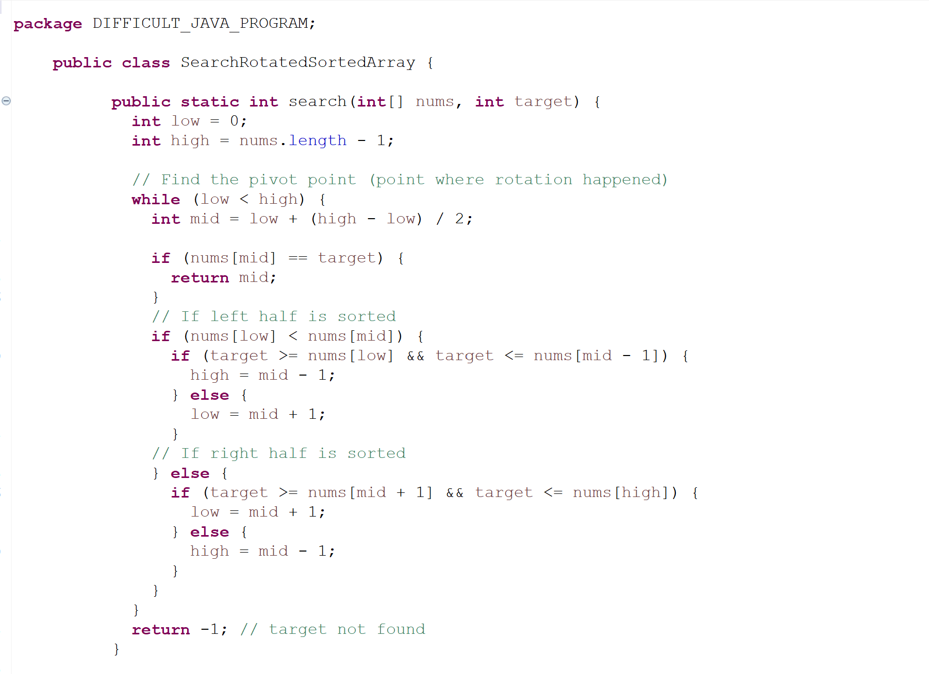
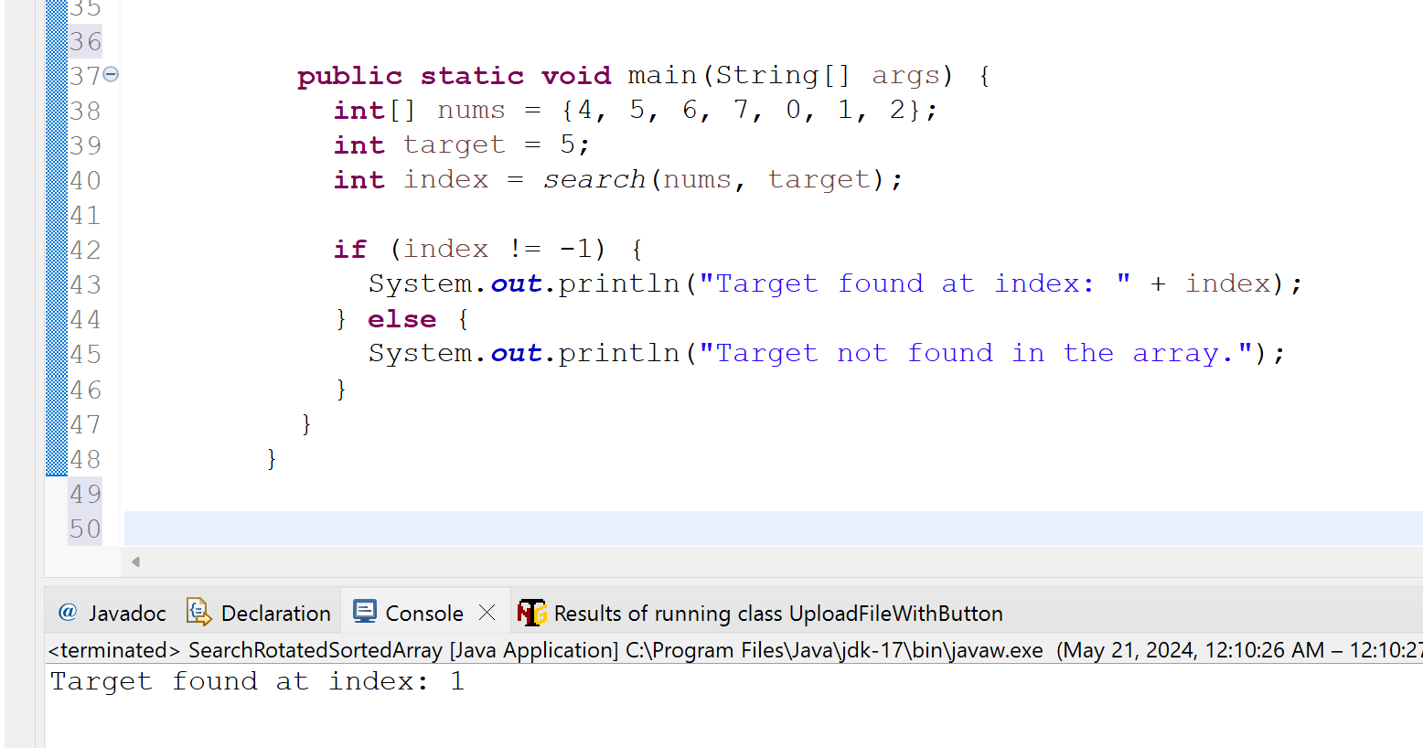
----------------------------------------------------------------------------------------------------------------------------
30. Write a program to find the shortest path in a weighted graph using Dijkstra's algorithm in Java.?
----------------------------------------------------------------------------------------------------------------------------
31. Create a Page Object Model for the login page of a website. Use Page Factory to initialize the elements. Write a TestNG test to verify successful login with valid credentials.
Ans: added git link below. ctrl+click on the link

https://github.com/kazitami/BOOTCAMP1/commit/c3a21f7278df76844008dcf81a792dfdf717e632#diff-437269352f98a6aff86a10256c94a558314a6bf1e56402ce0e6c153949cdb1fd

----------------------------------------------------------------------------------------------------------------------------
32. Create a Page Object Model for the shopping cart page of a website. Use Page Factory to initialize the elements. Write a TestNG test to add a product to the cart, navigate to the cart page, and verify that the product is added to the cart.
Ans: added git link below. ctrl+click on the link

https://github.com/kazitami/BOOTCAMP1/commit/febd205217709d534ebee951674b59c4f398d2b6#diff-62b43f50f320e62808f65c509d69bca6892c743e61e53c30ef2c1f6838109f92

----------------------------------------------------------------------------------------------------------------------------
33. Create a Page Object Model for the search page of a website. Use Page Factory to initialize the elements. Write a TestNG test to search for a product, verify that the search results are displayed, and click on a specific product to navigate to its details page.
Ans: added git link below. ctrl+click on the link

https://github.com/kazitami/BOOTCAMP1/commit/541db9cfb888ad203e6c648c79156367476e616e#diff-0d283aaca20cc17b352173eabce8cb8ab381a93f5ea125eccbeda1c8e2f4b657

----------------------------------------------------------------------------

MEDIUM
----------------------------------------------------------------------------------------------------------------------------
34. What is the difference between an abstract class and an interface in Java?
Ans:
1. Abstract class can have abstract and non-abstract methods. Interface can have only abstract methods.
2. Abstract class achieves partial abstraction (0 to 100%) where interface achieves fully abstraction (100%).
3.Abstract class contains abstract keyword to declaration. Interface use Interface keyword
----------------------------------------------------------------------------------------------------------------------------
35. What is the purpose of the static keyword in Java?
Ans:
The static keyword in Java is used to share the same variable or method of a given class. The users can apply static keywords with variables, methods, blocks, and nested classes.
----------------------------------------------------------------------------------------------------------------------------
36. What is the purpose of the final keyword in Java?
Ans: The final keyword in Java is used to indicate that a variable, method, or class cannot be modified or extended.
- Prevents accidental modification or important data
- Improves performance
----------------------------------------------------------------------------------------------------------------------------
37. What is the difference between a checked and an unchecked exception in Java?
Ans: In java, Exception is an unwanted or unexpected event, which occurs during the execution of a program at the runtime, that disrupts the normal flow of the programs instructions.
In java , there are two types of exceptions:
1.Checked exception
2. Unchecked exception
Checked exception happen at compile time when the source code is transformed into an executable code.
Unchecked exception happen at runtime when the executable program starts running.

----------------------------------------------------------------------------------------------------------------------------
38. What is the difference between a stack and a queue data structure in Java?
Ans:

Stack | Queue
It follows the principle LIFO(Last in – First out) | It follows the principle FIFO(First in – First out)
It has simpler implementation | It has a comparatively complex implementation than a stack.
It does not have any types | It has three types of like priority queue, circular queue and double ended queue.
A stack is visualized as a vertical colleciton. | A queue is visualized as a horizontal collection.

----------------------------------------------------------------------------------------------------------------------------
39. What is the purpose of the synchronized keyword in Java?
Ans:
The synchronized keyword in Java is a powerful tool for achieving thread safety and synchronization in multithreaded applications. By using synchronized blocks or synchronized methods, you can control concurrent access to shared resources, prevent data inconsistencies, and ensure proper thread synchronization
----------------------------------------------------------------------------------------------------------------------------
40. What is the purpose of the volatile keyword in Java?
Ans:
The volatile keyword in Java is used to indicate that a variable value may be modified by multiple threads simultaneously. The volatile keyword is a powerful tool that can be used to ensure that shared data is always consistent in multithreaded applications. However, it is important to use the volatile keyword carefully, as it can also lead to performance problems if it is used incorrectly.
----------------------------------------------------------------------------------------------------------------------------
41. What is the purpose of the transient keyword in Java?
Ans: The transient keyword provides a way to fine-tune the serialization process, balancing security, efficiency, and accurate representation of an object's state.

- Security: Excluding sensitive data like passwords from serialized objects to prevent unauthorized access.
- Efficiency: Avoiding redundant storage of data that can be recomputed from other serialized information.
- Compatibility: Handling non-serializable objects referenced by a variable by preventing serialization errors.
- State Management: Focusing serialization on the core state of an object and excluding transient variables that might hold temporary or calculated values.
----------------------------------------------------------------------------------------------------------------------------
42. What is the difference between the equals() and hashCode() methods in Java?
Ans:

equals() | hashCode()
Compares object content for equality | Generates a unique (ish) integer hash code
Inherited from Object class | Inherited from Object class
Focuses on Object state | Focuses on Object state as an integer representation
Compares object equality | Performance optimization in hash-based collections

----------------------------------------------------------------------------------------------------------------------------
43.What is the purpose of the finalize() method in Java?
Ans:“finalize” is a method in java that is called by the garbage collector before an object is garbage collected and can be overridden to perform any necessary cleanup before the object is destroyed.
Finalize Method in Java is not guaranteed to be called at any particular time or at all. So relying on it for critical cleanup operations can be risky.
----------------------------------------------------------------------------------------------------------------------------
44. What is the purpose of the this keyword in Java?
Ans: The this keyword refers to the current object in a method or constructor. The most common use of the “this” keyword is to eliminate the confusion between class attributes and parameters with the same name.
- “this” keyword to refer to current class instance variable
- “this” keyword to return the current class instance
- “this” keyword as an argument in the constructor call
----------------------------------------------------------------------------------------------------------------------------
45. What is the difference between a superclass and a subclass in Java?
Ans:
Super class | subclass
A super class is the class from which many subclasses can be created. | A subclass is a class derived from the superclass.
The subclasses inherit the characteristics of a superclass. | It inherits the properties of the superclass.
The superclass is also known as the parent class or base class. | Subclass also contains attributes of its own.
Vehicle is the Superclass | Car, Truck and Motorcycle are subclass

----------------------------------------------------------------------------------------------------------------------------
46. What is the purpose of the package keyword in Java?
Ans:The package keyword creates a package. A package in Java is used to group related classes. Think of it as a folder in a file directory. We use packages to avoid name conflicts, and to write a better maintainable code.
----------------------------------------------------------------------------------------------------------------------------
47. What is the difference between an instance variable and a class variable in Java?
Ans:
Instance variable | Class variable
- normally retains values as long as the object exists. | normally retains values until the program terminates.
- accessed directly by calling variable names inside the class. | accessed by calling with the class name.
- variables are declared without using the static keyword. | variables are declared using the keyword static.
- created when an instance of the class is created. | created when the program begins to execute.

----------------------------------------------------------------------------------------------------------------------------
48. What is the purpose of the instanceof operator in Java?
Ans: The java “instanceof” operator is used to test whether the object is an instance of the specified type(class or subclass or interface). It is also know as type comparison operator because it compares the instance with type. It returns either true or false.
----------------------------------------------------------------------------------------------------------------------------
49. What is the purpose of the super keyword in Java?
Ans:
The super keyword in Java is a reference variable which is used to refer immediate parent class object. Whenever you create the instance of subclass, an instance of parent class is created implicitly which is referred by super reference variable.
----------------------------------------------------------------------------------------------------------------------------
50. What is the purpose of the abstract keyword in Java?
Ans: The abstract keyword is used to create an abstract class and method in java. The abstract keyword in Java is used to achieve abstraction. To access abstract class, it must be inherited from another class.
----------------------------------------------------------------------------------------------------------------------------
51. What is the purpose of the interface keyword in Java?
Ans: The interface keyword in java use to create interface class to achieve 100% abstraction. Interfaces are also used to achieve polymorphism in Java. To access the interface methods, the interface must be “implemented” by another class with the implement keyword.
----------------------------------------------------------------------------------------------------------------------------
52. What is the difference between a private and a protected access modifier in Java?
Ans:
Protected | Private
- The keyword used is ‘protected’ | The keyword is used is ‘private’
- Protected can be used within the same calss | Private can be used within a same class
- Protected can be used in different package subclass | Private can not be used in different package subclass
- Protected can not be used in different package non-subclass | Private can not be used in different package non-subclass

----------------------------------------------------------------------------------------------------------------------------
53. What is the purpose of the throws keyword in Java?
Ans:
- to specify the exception type
- to indicate that the method will throw an unchecked exception.
- To specify the exception msg
- to indicate that the method will throw an unchecked exception
----------------------------------------------------------------------------------------------------------------------------
10 Java Programming Questions:
----------------------------------------------------------------------------------------------------------------------------

54. Write a Java program to find the factorial of a number using recursion.
Ans: added git link below. ctrl+click on the link below
https://github.com/kazitami/BOOTCAMP1/commit/b7dd270c62d202550a7a268bc45e5e79acec193b
----------------------------------------------------------------------------------------------------------------------------

55. Write a Java program to check if a given number is a palindrome or not.
Ans: added git link below. ctrl+click on the link below
https://github.com/kazitami/BOOTCAMP1/commit/04a3707b38652e0cb41f7f2c5a04d0b751ed02a1
----------------------------------------------------------------------------------------------------------------------------
56. Write a Java program to check if a given string is a palindrome or not.
Ans: added git link below. ctrl+click on the link below
https://github.com/kazitami/BOOTCAMP1/commit/8801d5f8bb7882fa3f38eca10e16106e4f66de7a
----------------------------------------------------------------------------------------------------------------------------
57. Write a Java program to reverse a given string without using any built-in functions.
Ans:
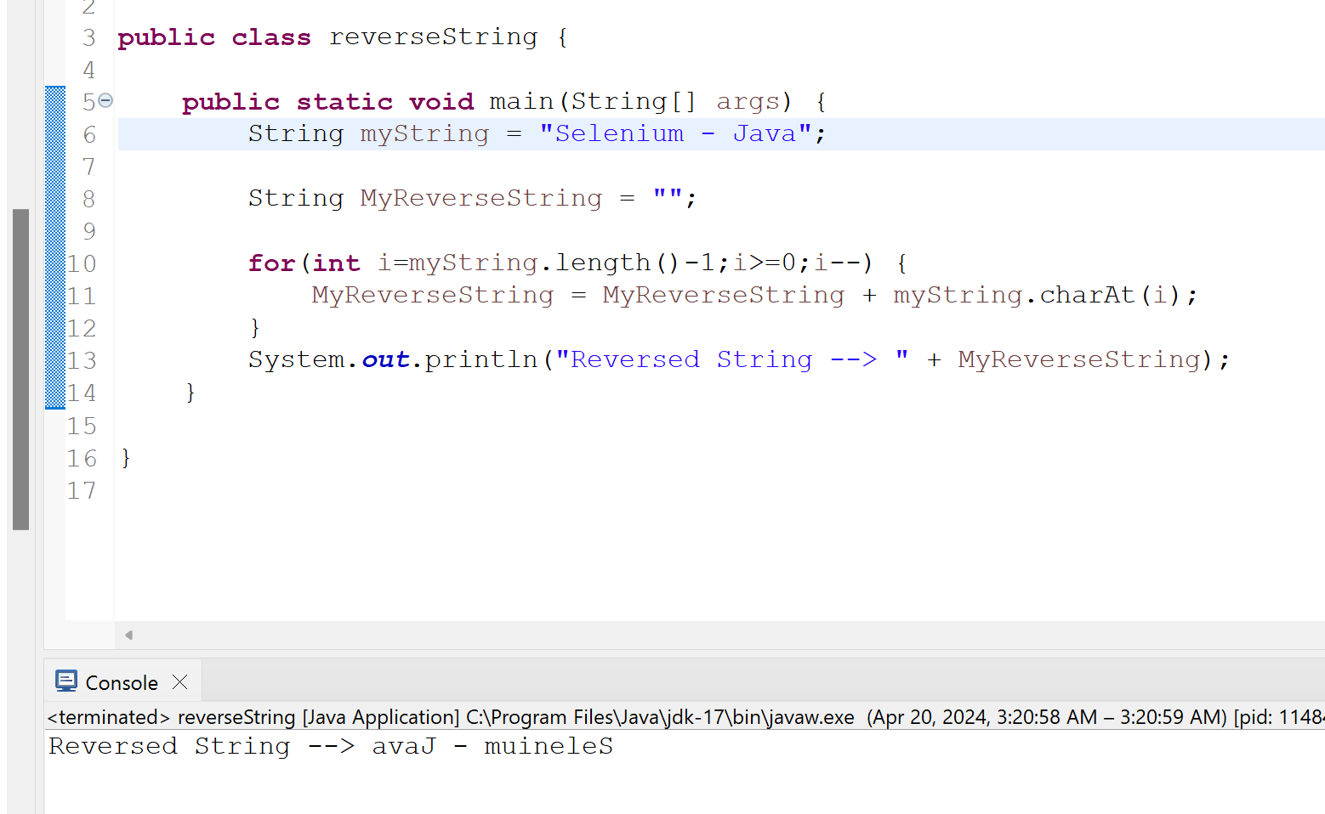
----------------------------------------------------------------------------------------------------------------------------

58. Write a Java program to find the second highest number in an array.
Ans:
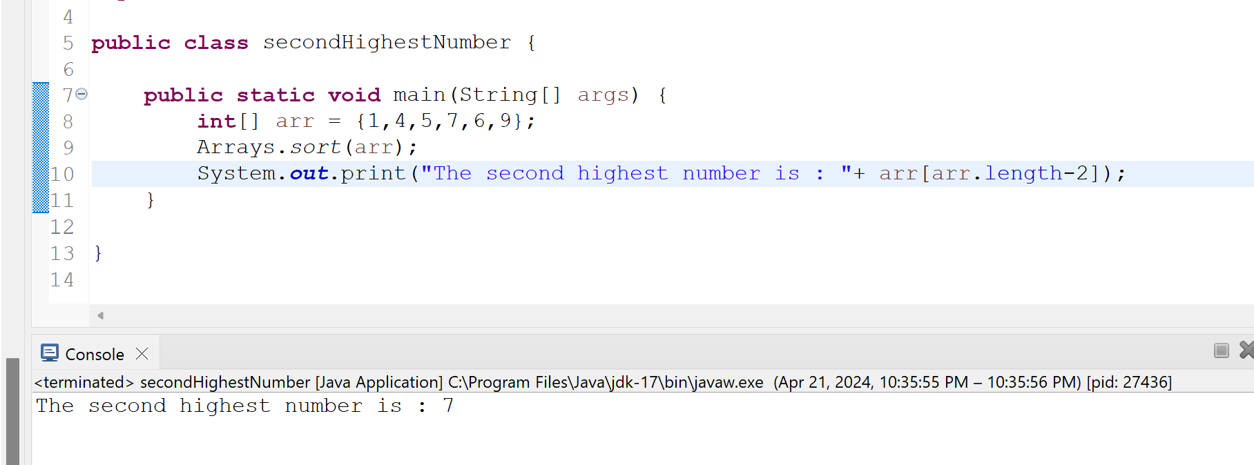
----------------------------------------------------------------------------------------------------------------------------

59. Write a Java program to implement bubble sort algorithm.
Ans:
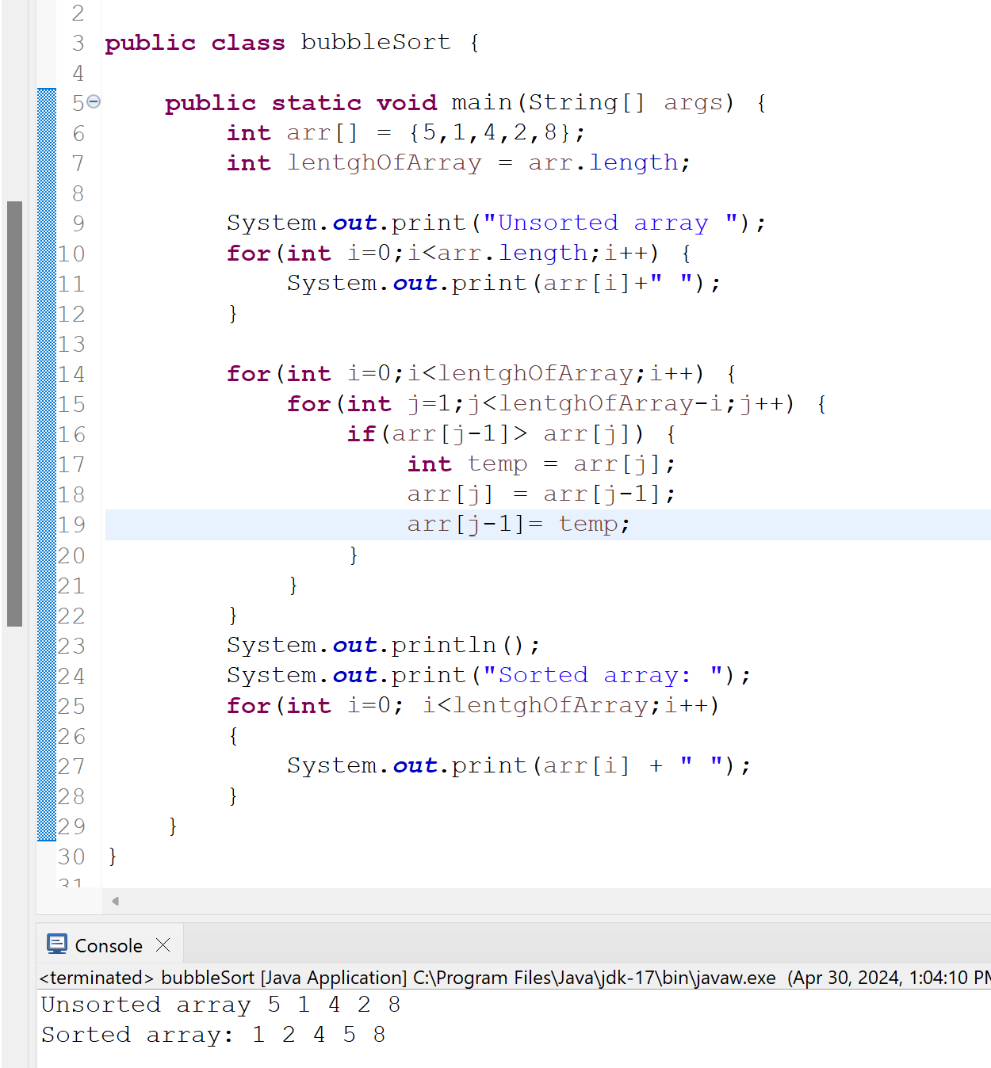
----------------------------------------------------------------------------------------------------------------------------
60. Write a Java program to implement selection sort algorithm.
Ans:
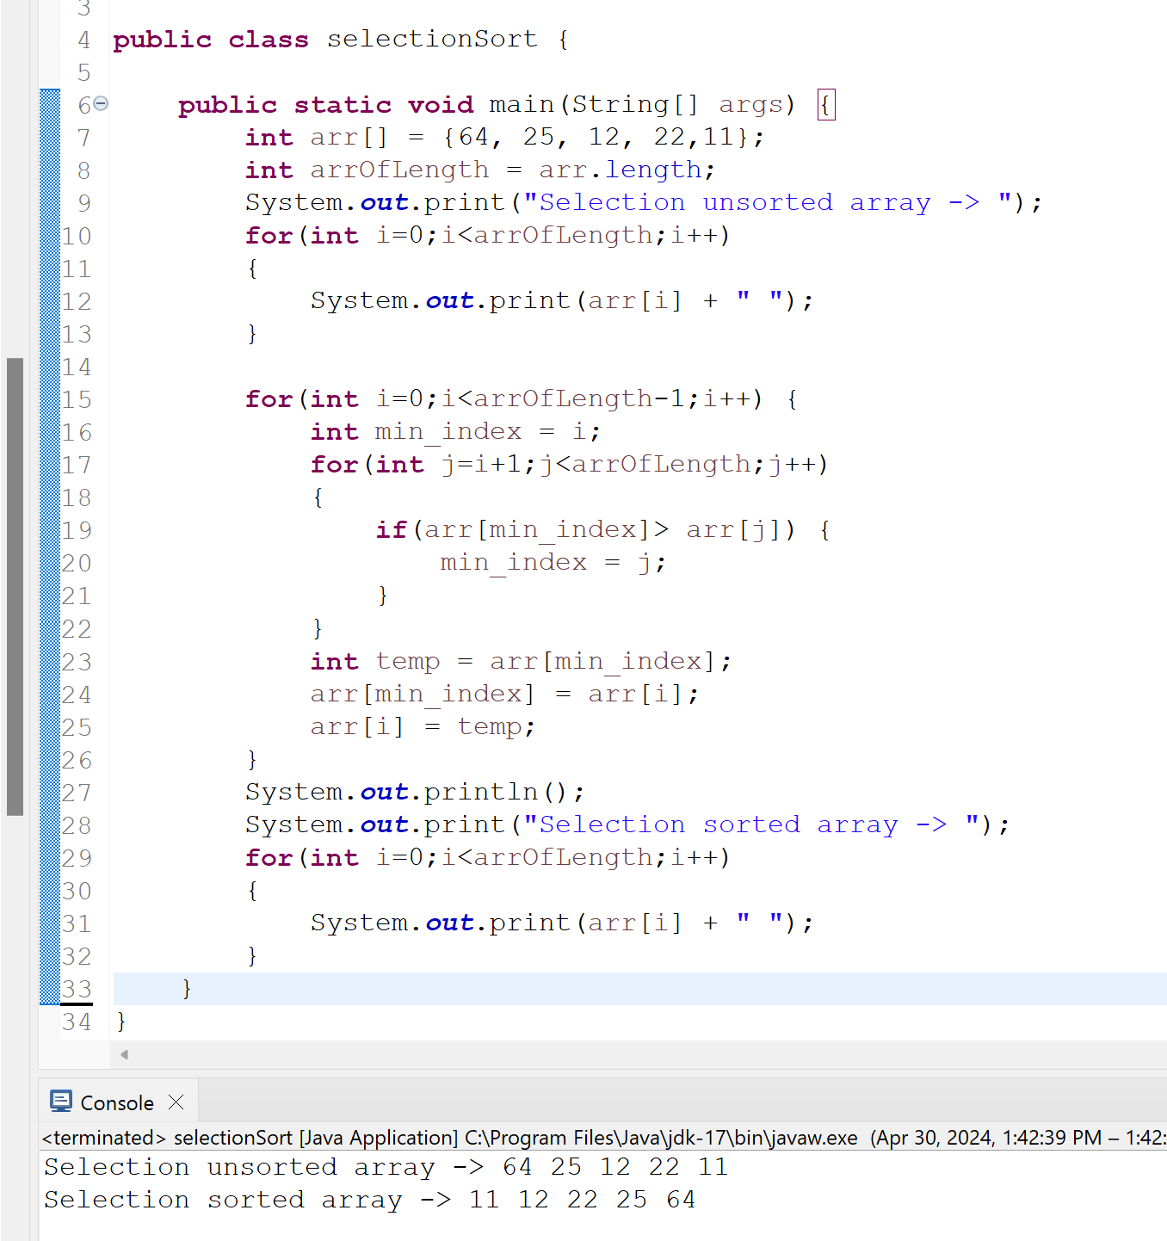
----------------------------------------------------------------------------------------------------------------------------

61. Write a Java program to implement insertion sort algorithm.
Ans:
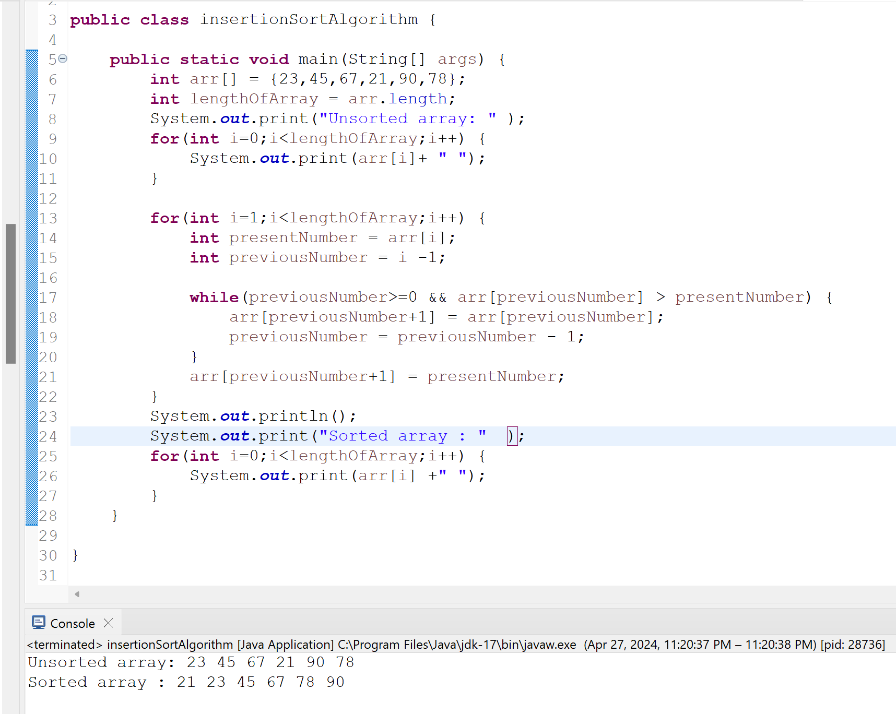
----------------------------------------------------------------------------------------------------------------------------
62. Write a Java program to implement binary search algorithm.
Ans:
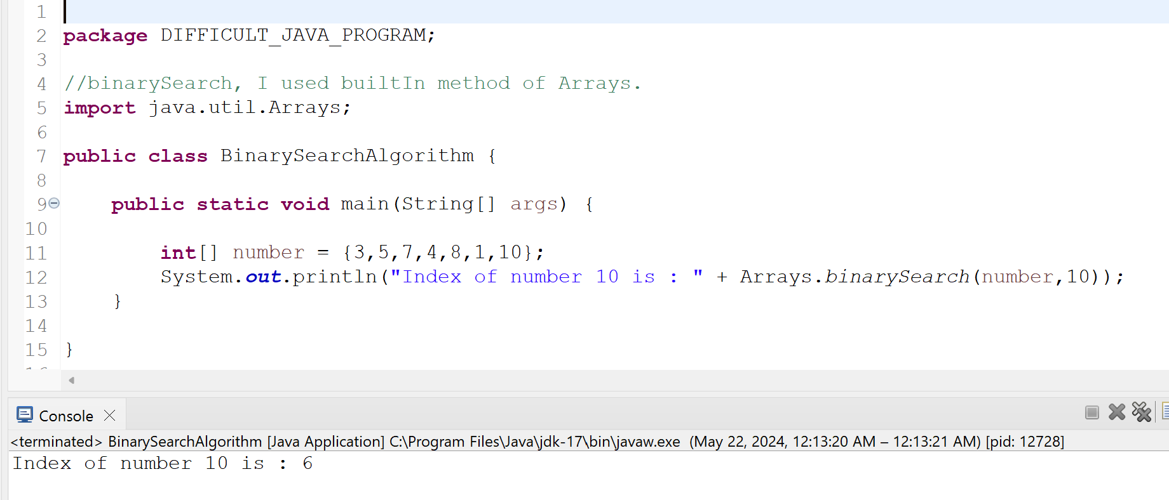
----------------------------------------------------------------------------------------------------------------------------
63. Write a Java program to count the number of words in a given string.
Ans:
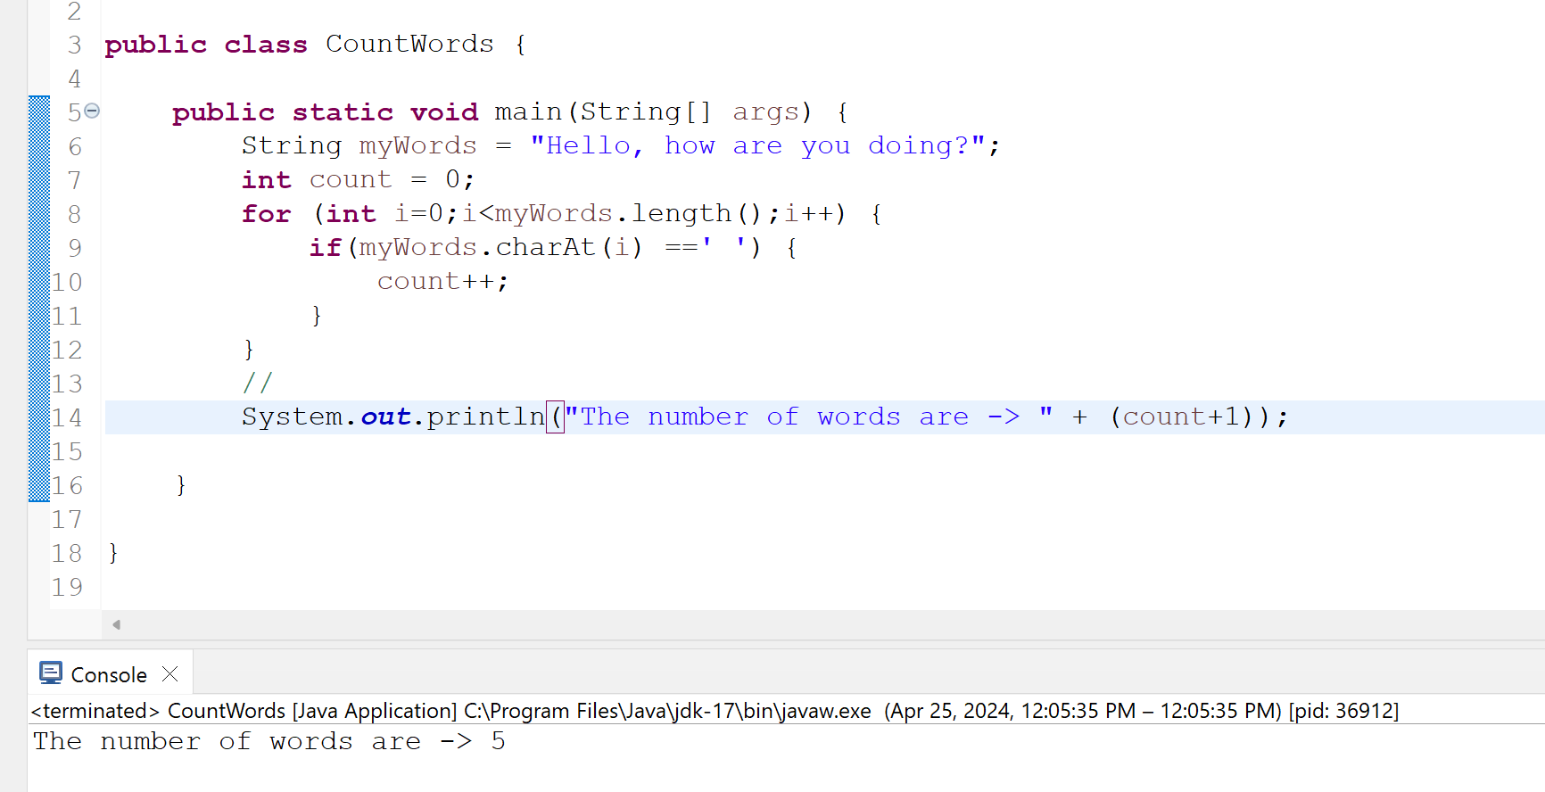
----------------------------------------------------------------------------------------------------------------------------
3 Selenium Framework Questions:
----------------------------------------------------------------------------------------------------------------------------
64. Create a Page Object Model for the registration page of a website. Use Page Factory to initialize the elements. Write a TestNG test to verify successful registration with valid credentials.
Ans: added git link below. ctrl+click on the link
https://github.com/kazitami/BOOTCAMP1/commit/2bbc5dee72a0b29f2a328b6fd85494d0be8e78c3

----------------------------------------------------------------------------------------------------------------------------
65. Create a Page Object Model for the checkout page of a website. Use Page Factory to initialize the elements. Write a TestNG test to add a product to the cart, navigate to the checkout page, and verify that the correct product is being purchased.
Ans: added git link below. ctrl+click on the link
https://github.com/kazitami/BOOTCAMP1/commit/f81c910c0c3f090a861879ba0165d9129eb5f7cc#diff-98a1494699ea0c5e023779450982bb8513d56edd5cdf212589b034e5f041700c
----------------------------------------------------------------------------------------------------------------------------
66. Create a Page Object Model for the home page of a website. Use Page Factory to initialize the elements. Write a TestNG test to navigate to the home page, verify the presence of certain elements, and click on a link to navigate to a different page.
Ans: added git link below. ctrl+click on the link
https://github.com/kazitami/BOOTCAMP1/commit/6e63dedc0032a53f0d69e3e77aa659776f4258fb
----------------------------------------------------------------------------

EASY
----------------------------------------------------------------------------------------------------------------------------
67. What is the purpose of the public keyword in Java?
Ans:
The public keyword is an access modifier in Java that makes classes, methods, and fields accessible to any other class. This means that any class can access a public class, methods.
----------------------------------------------------------------------------------------------------------------------------
68. What is the purpose of the private keyword in Java?
Ans:
The private keyword in Java is an access modifier that restricts access to a class's fields and methods. Only methods within the same class can access private fields and methods. This helps to protect the class's data and ensures that it is only modified in a controlled manner.
----------------------------------------------------------------------------------------------------------------------------
69. What is the purpose of the protected keyword in Java?
Ans:
The "protected" keyword in Java is an access modifier used to restrict the visibility of a class, method, or variable. When a class member is marked as protected, it can be accessed by the members of its own class, its subclasses, and classes in the same package.
----------------------------------------------------------------------------------------------------------------------------
70. What is the purpose of the static keyword in Java?
Ans: Static keyword in java is mainly used for memory management. The static keyword in Java is used to share the same variable or method of a given class.Users can use static keyword with variables, methods, blocks and nested classes.
----------------------------------------------------------------------------------------------------------------------------
71. What is the purpose of the final keyword in Java?
Ans:
The final keyword is a non-access modifier used for classes, attributes and methods, which makes them non-changeable (impossible to inherit or override). The final keyword is useful when you want a variable to always store the same value.
----------------------------------------------------------------------------------------------------------------------------
72. What is the purpose of the abstract keyword in Java?
Ans:
The abstract keyword is used to achieve abstraction, which is one of the pillars of Object Oriented Programming (OOPs). Abstraction is the process of hiding the implementation details of a class and exposing only the necessary information to the user. This makes it easier to understand and use the class, and it also makes it easier to change the implementation without affecting the user.
----------------------------------------------------------------------------------------------------------------------------
73. What is the purpose of the interface keyword in Java?
Ans:
The interface keyword in java use to create interface class to achieve abstraction. Interfaces are also used to achieve polymorphism in Java.
----------------------------------------------------------------------------------------------------------------------------
74. What is the purpose of the new keyword in Java?
Ans: The Java new keyword is used to create an instance of the class.
- It is used to create the object.
- It allocates the memory at runtime.
- It invokes the object constructor

----------------------------------------------------------------------------------------------------------------------------
75. What is the difference between a class and an object in Java?
Ans:
  - An object is an instance of a class. And a class used to create the objects.
  - When class is created,no memory is allocated. But when Object are created ,they allocated memory.
  - A class is a logical entity and an object is a physical entity.
  - Class declared with class keyword and object gets created with new keyword.
----------------------------------------------------------------------------------------------------------------------------
76. What is the purpose of the main() method in Java?
Ans:
Main method is the entry point for executing a Java program. The main method can contain code to execute or call other methods, and it can be placed in any class that's
part of a program.
----------------------------------------------------------------------------------------------------------------------------
77. What is the difference between a float and a double in Java?
Ans:
- The float keyword in Java is a primitive data type, single-precision 32 bit and double keyword in Java is a primitive data type, double-precision 64-bit
- The float data type precision is up to 6 to 7 decimal digits. And double data type can provide precision up to 15 to 15 decimal digits.
- Float data type consumes 4 byte or 32 for storing a variable and double data type consumes 8 byte or 64 bits for storing a variable
----------------------------------------------------------------------------------------------------------------------------
78. What is the difference between an int and a long in Java?
Ans:
- Int data type is 32 bits and long data type is 64 bits.
- Wrapper class int is integers and long is Long
- int range is -2,147,483,648 to 2,147,483,647 and long range is -9,223,372,036,854,775,808 to -9,223,372,036,854,775,807
In general, you should use int for storing small numbers, and long for large numbers.

----------------------------------------------------------------------------------------------------------------------------
79. What is the purpose of the System.out.println() method in Java?
Ans: The System.out.println() method in Java is used to print text on the console.And it appends a new line character.
----------------------------------------------------------------------------------------------------------------------------
80. What is the purpose of the Scanner class in Java?
Ans: The Scanner class in Java is used to get user input and parse them into primitive data type such as int, double or default string.
----------------------------------------------------------------------------------------------------------------------------
81. What is the purpose of the Math class in Java?
Ans: Java Math class provides several methods to work on math claculations like min(), max(), avg(), sin(), cos(), tan(), round() and many more.
----------------------------------------------------------------------------------------------------------------------------
82. What is the purpose of the String class in Java?
Ans: A primary purpose of strings is to store human-readable text, like words and sentences. String class is a final class, which means that cannot be extended. It is also as immutable class, which means its value cannot be changed. The String class has a number of methods that can be used to manipulate strings. These methods include:
charAt(), compareTo(),concat(), contains(),endsWith(),equals() and more.
----------------------------------------------------------------------------------------------------------------------------
83. What is the purpose of the StringBuilder class in Java?
Ans:
StringBuilder is a class, which is used to create mutable strings. Object can be modified. Performance-wise StringBuilder is very fast because it will use the same instance of StringBuilder object to perform any operation like inserting a value in the existing string. It reduces memory usage.
----------------------------------------------------------------------------------------------------------------------------
84. What is the purpose of the equals() method in Java?
Ans:
The equals() method compares two strings, and returns true if the strings are equal, and false if not.
----------------------------------------------------------------------------------------------------------------------------
85. What is the purpose of the compareTo() method in Java?
Ans: The compareTo() method in java used to compare two strings.It compares the strings character by character, based on their Unicode values. The compareTo() method is often used to sort strings in alphabetical order. It also be used to compare strings for equality.
----------------------------------------------------------------------------------------------------------------------------
86. What is the purpose of the toString() method in Java?
Ans:
A toString() is an in-built method in Java that returns the value given to it in string format. Hence, any object that this method is applied on, will then be returned as a string object.
----------------------------------------------------------------------------------------------------------------------------
10 Java Programming Questions:
----------------------------------------------------------------------------------------------------------------------------
87. Write a Java program to print "Hello, World!" to the console.
Ans:
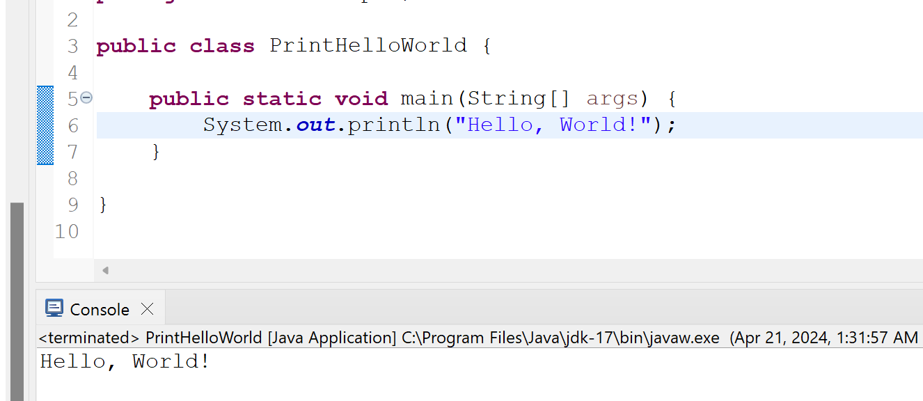
----------------------------------------------------------------------------------------------------------------------------
88. Write a Java program to find the sum of two numbers.
Ans:
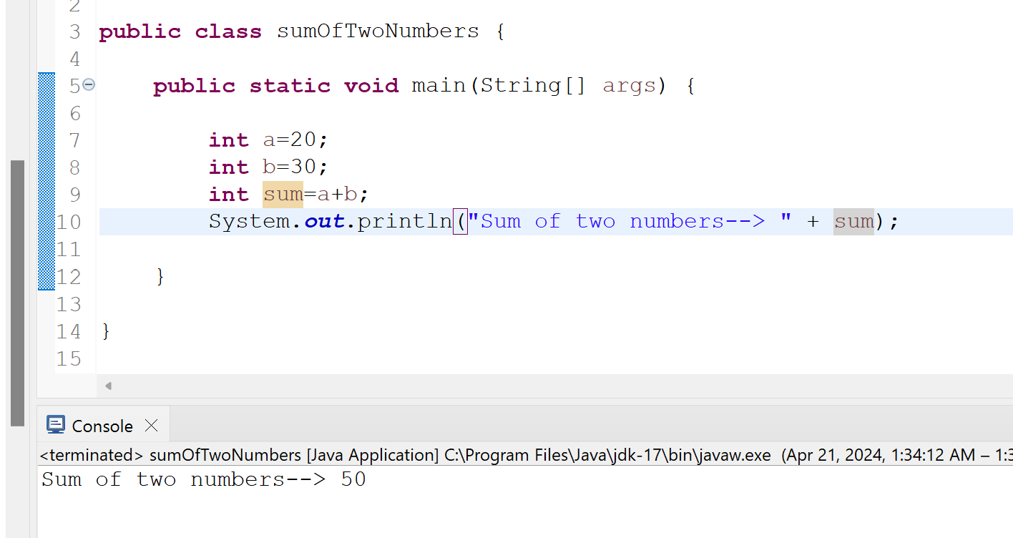
----------------------------------------------------------------------------------------------------------------------------

89. Write a Java program to find the average of three numbers.
Ans:

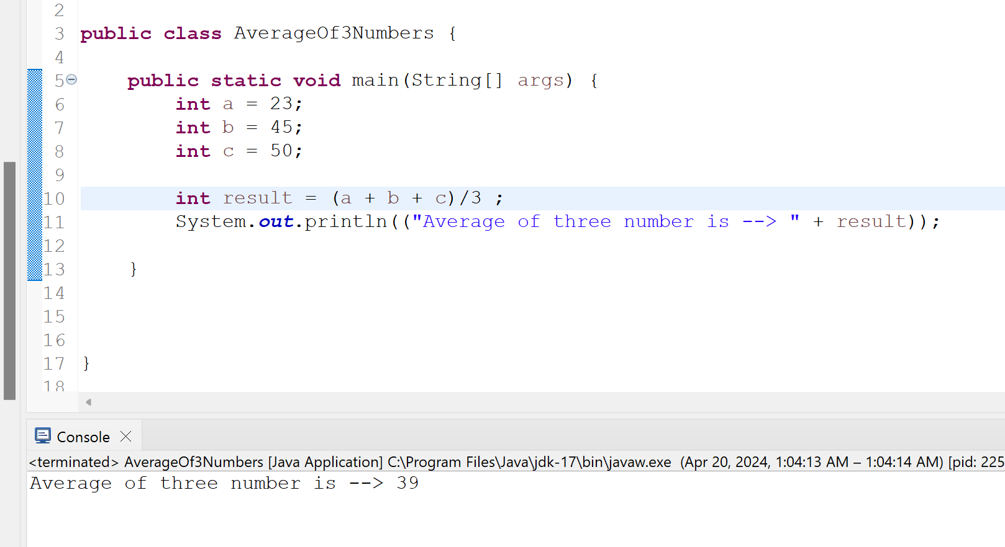

----------------------------------------------------------------------------------------------------------------------------
90. Write a Java program to check if a given number is even or odd.
Ans:
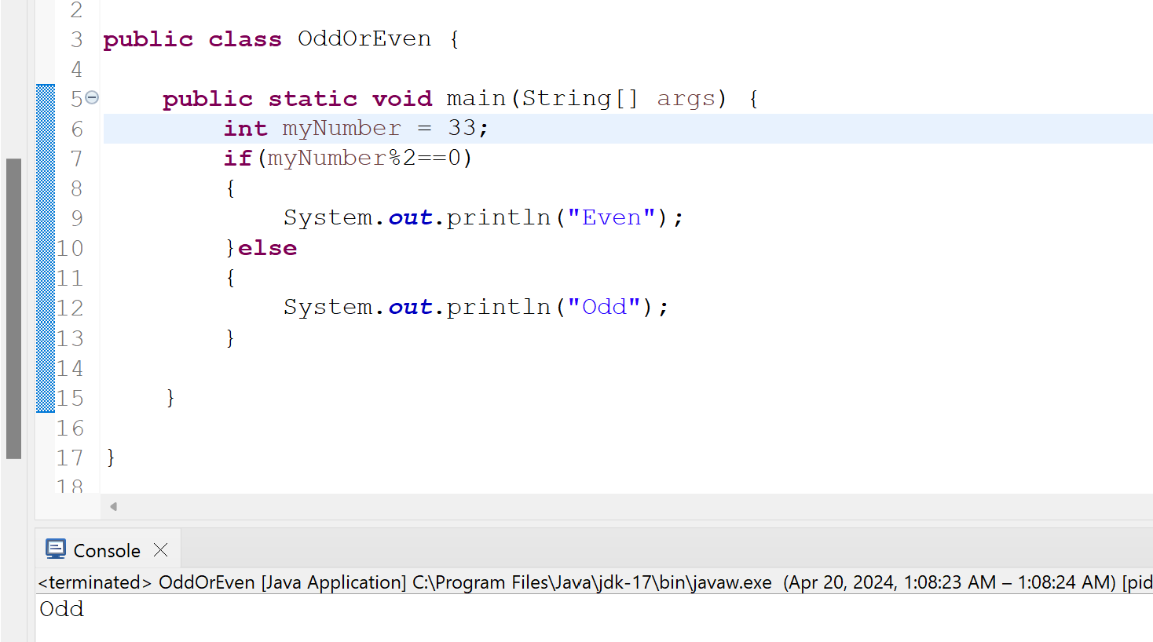
----------------------------------------------------------------------------------------------------------------------------
91. Write a Java program to check if a given number is prime or not.
Ans: added git link below. ctrl+click on the link below
https://github.com/kazitami/BOOTCAMP1/commit/1fe2ce14667a04cff6df944e576bf8dae00e80f9
----------------------------------------------------------------------------------------------------------------------------
92. Write a Java program to check if a given string is a palindrome or not.
Ans: added git link below. ctrl+click on the link below
https://github.com/kazitami/BOOTCAMP1/commit/063e42cdc812f42fa3070f6c272ddfedf8e1ab5c
----------------------------------------------------------------------------------------------------------------------------
93. Write a Java program to reverse a given string.
Ans:

----------------------------------------------------------------------------------------------------------------------------
94. Write a Java program to implement a simple calculator.
Ans: added git link below. ctrl+click on the link below
https://github.com/kazitami/BOOTCAMP1/blob/master/src/main/java/EASY_JAVA_PROGRAM/SimpleCalculator.java
----------------------------------------------------------------------------------------------------------------------------
95. Write a Java program to convert Fahrenheit to Celsius.
Ans:
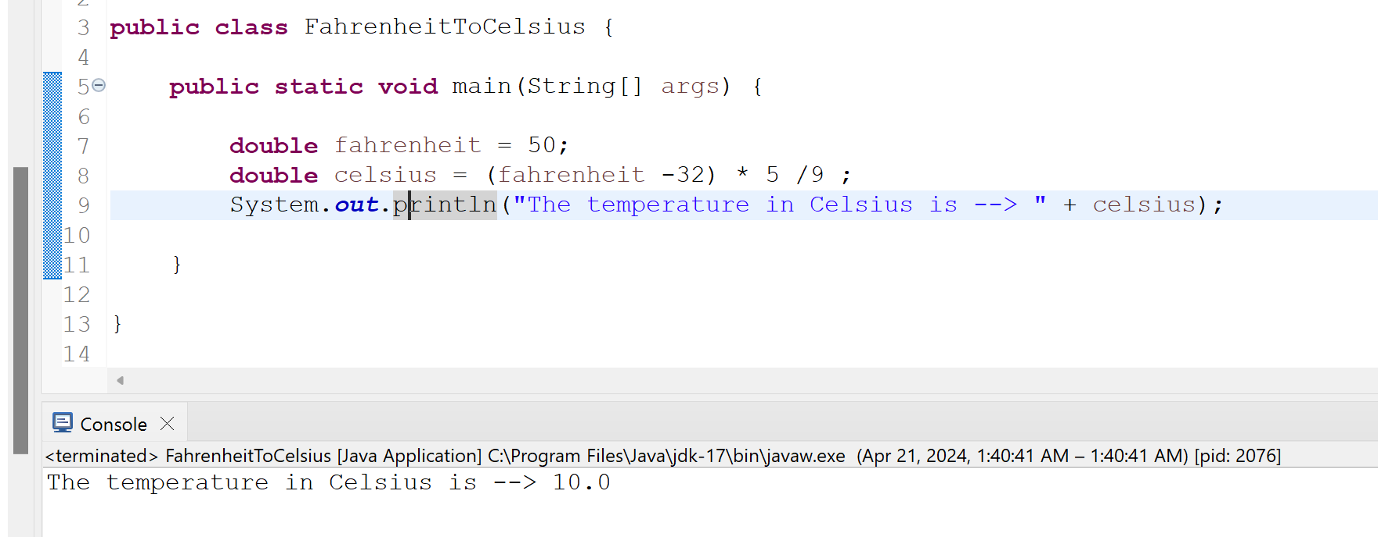
----------------------------------------------------------------------------------------------------------------------------
96. Write a Java program to generate a random number between 1 and 100.
Ans:
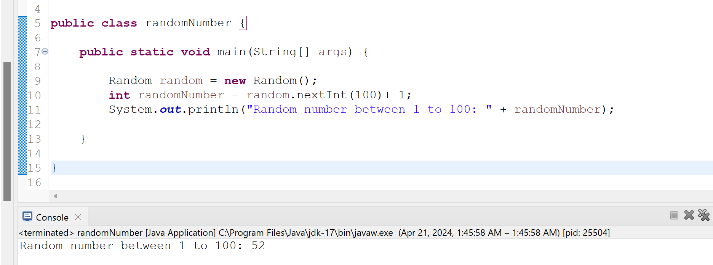
----------------------------------------------------------------------------------------------------------------------------
3 Selenium Framework Questions:
----------------------------------------------------------------------------------------------------------------------------
97. Write a TestNG test to navigate to a website and verify the title of the page.
Ans: added git link below. ctrl+click on the link
https://github.com/kazitami/BOOTCAMP1/commit/58ce37da538548a181bfdb5bf63c44c2a27a30d2
----------------------------------------------------------------------------------------------------------------------------
98. Write a TestNG test to fill out a login form on a website and verify successful login with valid credentials.
Ans: added git link below. ctrl+click on the link
https://github.com/kazitami/BOOTCAMP1/commit/163d37367dbaaf3f9b6b6e25e1d811dfe536bcf8
----------------------------------------------------------------------------------------------------------------------------
99. Write a TestNG test to navigate to a website, click on a link to navigate to a different page, and verify the presence of certain elements on the new page.
Ans: added git link below. ctrl+click on the link
https://github.com/kazitami/BOOTCAMP1/commit/560658498e80d9c798cdbb0b7fd6e9eda11cd2cc

